Unleashing Progress: The Information Age and Humanity’s End
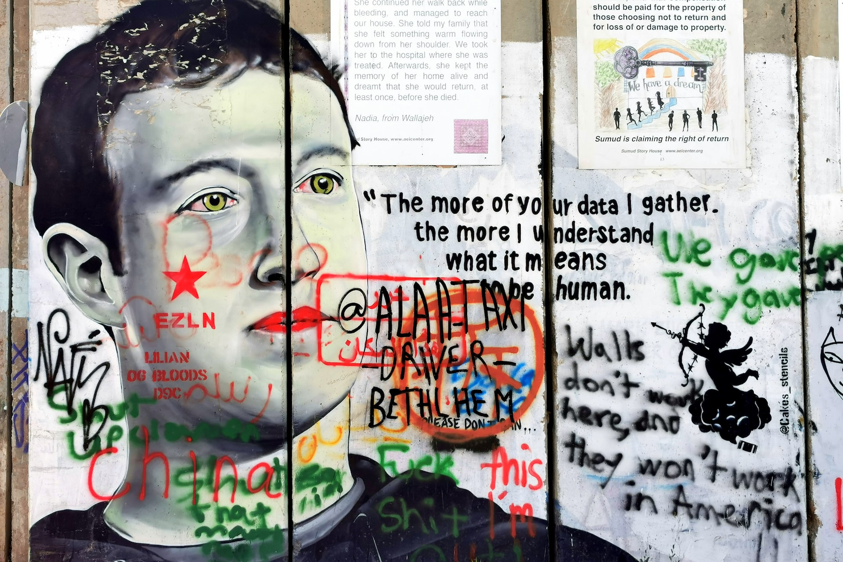

INTRODUCTION
Depression, addiction, and inequality are all on the rise. We hear people talk less about being in an ‘Information Age’ and more about being in a ‘Post-Truth Era’. Yet, we all seem to feel like progressions in technology have made our lives better, but if that’s the case, what is the cost? This short article will explore: the consequences of unleashing progress, whether there is still hope for a solution, or whether we are already too late. So, for clarity, we will not be weighing the pros and cons of technological advancement. Instead, we will explore the link between the information age and existential risks to find a better understanding of the problem we are faced with to hopefully define a solution.

THE POST TRUTH ERA: APATHY AND THE BURDEN OF CHOICE 
The average person with an education knows 20,000 words, but, across over 6000 languages, less than 100 of those words are universal (pg26). Some of these universal words being: ‘know’, ‘true’, ‘good’, and ‘bad’. So, in a post-truth world, what happens when we can no longer discern what is good or bad? Or between, what we know and what is true? In the book 'All Things Shining,' Harvard philosophers Kelly and Dreyfus state that modern society's excess of choice leads to an enslavement by our “obsessions, infatuations, or addictions”(pg12), illustrating the risks of an “infinite freedom...that mortal life cannot sustain"(pg 51). I believe this is an important place to start because as clinical psychologists would agree, when a problem is too abstract it becomes harder to relate to, and it is then harder to act. So, while our post-truth lives are oversaturated by information, entertainment, and social media, it is easy to see how we may feel a distance between ourselves and lofty problems like climate change, nuclear warfare, or artificial intelligence. After all, to quote Oxford philosopher Toby Ord, “major risks to our entire future are a new problem, and our thinking has not caught up” (pg7). However, as we will see later, it is the fact that we feel this apathy that is the danger.

SURVEILLANCE CAPITALISM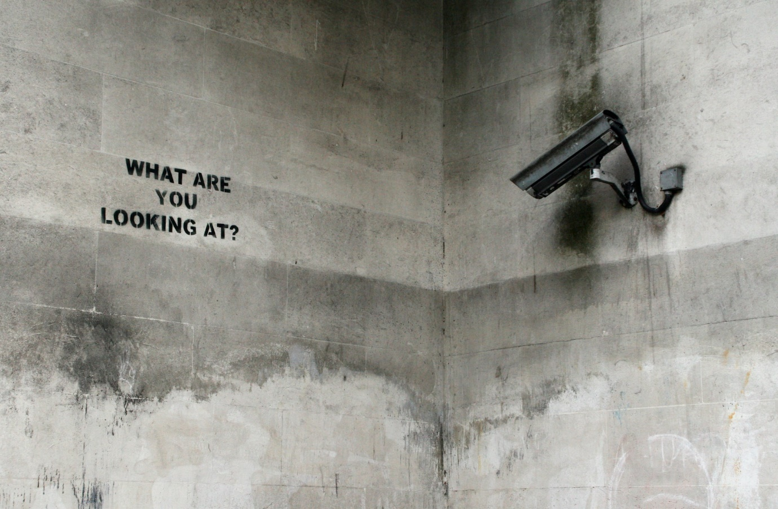
In Michael Moore's documentary ‘Capitalism: A Love Story’, he exposes the disturbing practice of "Dead Peasant Insurance", also known as "Corporate Owned Life Insurance". This is a common form of insurance policy that companies use to profit from the death of their employees. So consequently, we live in a time where we may have to ask ourselves the question, is it better for my company if I am alive or if I am dead? For me, this is a perfect example of how capitalism works, where everything and anything can be converted into capital, and profit is prioritized over life. So, why is this relevant? I believe that by understanding the nature of capitalism, it will help us to appreciate the severity of the next consequence: big tech’s profit-driven algorithms.
In 1997, Garry Kasparov, one of the greatest chess players in history, was beaten by Deep Blue, the chess-playing computer built by IBM. But while it only took IBM 6 years to defeat Kasparov’s lifetime of experience, today's tech giants have made this look like ancient history. In the documentary ‘Social Dilemma’, Tristan Harris, the former design ethicist for Google, states that the big tech companies use three types of algorithms that work alongside each other, each having a separate goal: (1) engagement (2) growth (3) profit or advertising. So, much like the purposes of a virus, these algorithms want us to engage with it, infect others, and feed it. Therefore, as the documentary tries to express, we have a supercomputer on the other side of our phone screen that is vastly more advanced than Deep Blue. But, instead of playing chess, it is programmed to monitor, predict, and influence our behaviour and emotions, all while adapting, getting better every day. We have already started to see the implications of this.
In “The Social Dilemma”, the documentary describes how Facebook gave Myanmar’s military and other actors “a new way to manipulate public opinion and to incite violence against the Rohingya Muslims”. This led to mass killings, mass rape, the burning of villages, a plethora of additional heinous crimes and 700,000 people fleeing the country. However, this is just one of many examples of how these algorithms have been used for nefarious purposes. So, it is reasonable to think this is surely a job for the big tech companies to regulate these algorithms. But, according to Tristan Harris, these companies are “trapped by a business model, an economic incentive, and shareholder pressure that makes it almost impossible to do something else”. Consequently, we must conclude that surveillance capitalism may indirectly pose the greatest risk to humanity’s survival. This being because “it’s the technology’s ability to bring out the worst in society” and it is the worst in society that is the real existential risk.

WHAT CAN WE DO?
In ‘The Precipice’ by Toby Ord, he writes that the international body responsible for the prohibition of bioweapons “has an annual budget of $1.4million–less than the average McDonald’s restaurant” (pg 57). After, he goes on to say that the entire spending on reducing the existential risks from A.I. is tens of millions of dollars, but the amount spent on improving A.I. is in the billions (pg57-58). This again seems to be capitalism in effect. Therefore, I am somewhat sceptical of the efficiency of top-down solutions like government regulations, education, and international relations. So instead, I will be focusing on what we can do on an individual level to make this problem less abstract and more actionable.
To start with, Toby Ord suggests a number of solutions like: finding a career with an ethical trajectory, becoming an effective altruist, being well informed on existential risks and participating in keeping a public or private conversation alive that covers these topics. But something I believe is an even easier first step, is learning the skill “meta-poeisis” posited by Kelly and Dreyfus (pg212). This being “the higher-order skill of recognizing when to rise up as one with the ecstatic crowd and when to turn heel and walk rapidly away” (pg 212). This could be in terms of activism, but it is more than that. The acquisition of this skill is more like the acquisition of freedom in these modern times. It is the skill of knowing when to put the phone down, and to spend time with your loved ones, or of learning which apps and websites respect your privacy, and which do not. And so, the master of living in this post truth era “will live attuned to the shining things and so will have opened a place to which all the gods may return” (pg221).

References

Ord, Toby. The Precipice: Existential Risk and the Future of Humanity. Penguin, 2020.
Orlowski, Jeff. The Social Dilemma. Netflix, 2020.
Moore, Michael. Capitalism: A Love Story. Overture Films, 2009.
Short, T. L. Knowledge: A Very Short Introduction. Oxford University Press, 2014.
Kelly, D., & Dreyfus, H. L. All Things Shining: Reading the Western Classics to Find Meaning in a Secular Age. New York: Free Press, 2011.

